Geospatial Distribution of Bottlenose Dolphins

AREA OF RESEARCH
Environment, marine; Conservation, marine

Supervisors / Research Group / Project Partners
Prof Christine Erbe (Supervisor); Director, Centre for Marine Science & Technology
08 9266 7543 C.Erbe@curtin.edu.au
Dr Kate Charlton-Robb (Co-Supervisor); Director, Marine Mammal Foundation (MMF)
kate@marinemammal.org.au

Research Project
The Burrunan dolphin (Tursiops australis) occurs as small, genetically distinct and isolated populations in coastal areas of southern Australia and is listed as threatened. MMF has studied the populations in Port Phillip Bay (PPB) & Gippsland Lakes (GL), VIC, Australia, for over a decade. There is a photo-ID catalogue of ~120 individuals in PPB and ~100 individuals GL. Dolphins rely heavily on sound production for navigating, foraging, communicating and socialising. Sound production is linked to behaviour, group cohesion and identification of individuals (signature whistles). Human presence (e.g., boats) can cause behavioural changes, displacement from important habitats, interference with dolphin communication and foraging, etc. Such disturbances can affect core biological activities of dolphins and ultimately their health and fitness. Understanding dolphin ecology is important for conservation management. Recent projects have been investigating population demographics, association patterns, behaviour, genetics, feeding ecology, toxicology, habitat characteristics and, preliminarily, bioacoustics. For the coming 2 years, boat-based fieldwork is scheduled for 22 days every 3 months across the two locations, and the Honours student will be able to participate in at least one season.

This Honours project will use passive acoustic monitoring (i.e., listening to dolphin sounds from underwater acoustic recordings) to document and map their distribution and analyse geospatial and temporal distribution patterns.

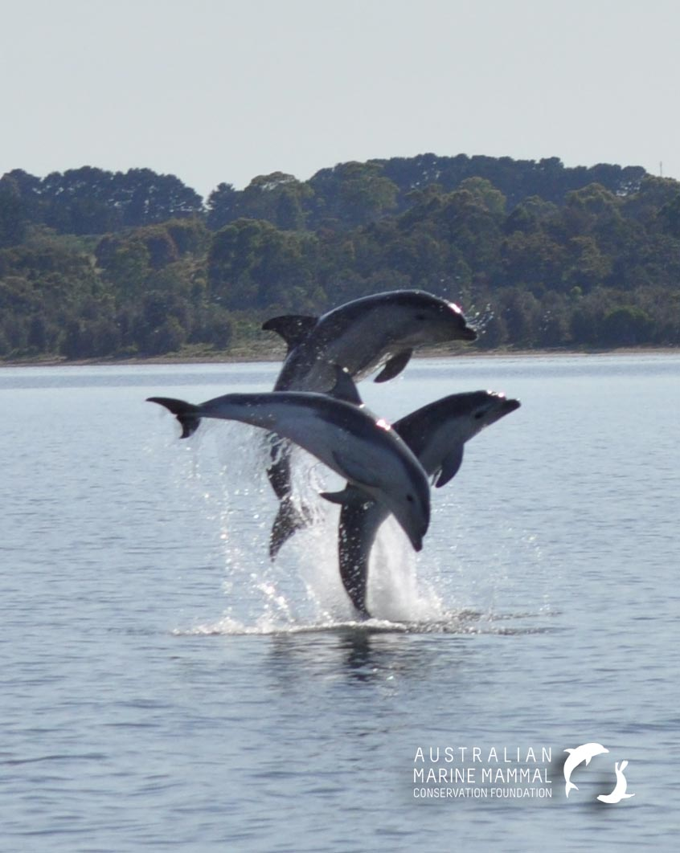
SUPPORT
All field-related costs are covered by an existing research grant, i.e., boats, fuel, accommodation while in the field, acoustic equipment incl. autonomous recorders and short-term suction-cup tags.

Figure: Photo of 3 Burrunan dolphins in the Gippsland Lakes, Victoria. Can you imagine a better site for field work ?!

