Submarine Related Research and Capability
The Centre for Marine Science and Technology (CMST) at Curtin University comprises a multi-skilled body of scientists and engineers. Since its foundation in 1985, the Centre has earned a reputation as a group which responds quickly to industry and government needs, producing the required outcomes on time and on budget.

Three modes of operation are available:
- Commercial-in-confidence consulting, research and development
- Accessing state and federal government research grant schemes
- Postgraduate student research. The student may be supplied by the client.

A wide range of clients have utilised the services of CMST including: the Defence Science and Technology Group (DST-G), the Department of Defence, the Office of Naval Research, L3 Nautronix, BHP Billiton, Woodside, Chevron, Santos, ExxonMobil, ConocoPhillips, Fugro, Western Geco, SKM, Jacobs, ERM, RPS, and many more.

Computational Hydrodynamics
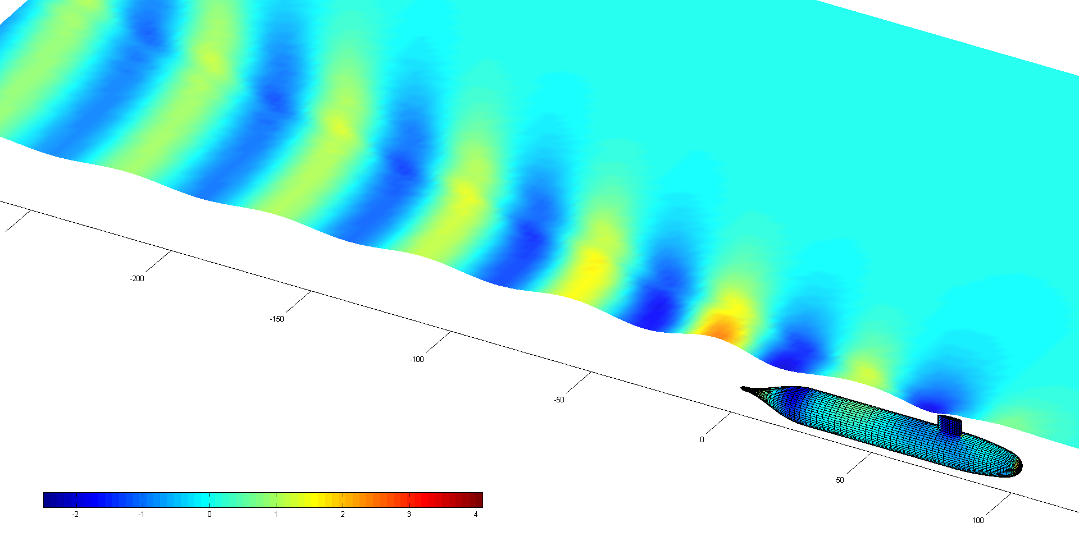
Hydrodynamic model output example for a submarine operating close to the sea surface: Wave elevations on free surface and hydrodynamic pressure head on submarine hull, both in metres.
CMST has particular expertise in predicting the hydrodynamic characteristics of vessels operating close to boundaries. This includes submarines operating near the sea surface and ships operating in shallow water. Predictions include the flow around the vessel, the wave field produced by the vessel, changes in trim and sinkage, and the resulting drag. Wave induced motions of vessels, including wave induced motions in shallow water, can also be predicted.

Computational Acoustics
CMST has developed highly efficient computational tools for modelling the scattering of sound by underwater structures and the radiation of sound by vibrating underwater structures based on the Fast Multipole Boundary Element Method (FMBEM). These tools make it practical to carry out calculations at higher frequencies and for larger structures than is possible with conventional commercial modelling packages. Fluid-structure interactions can be included by either coupling the fluid FMBEM model to a conventional Finite Element model or to an elastic FMBEM model that has also been developed by CMST.
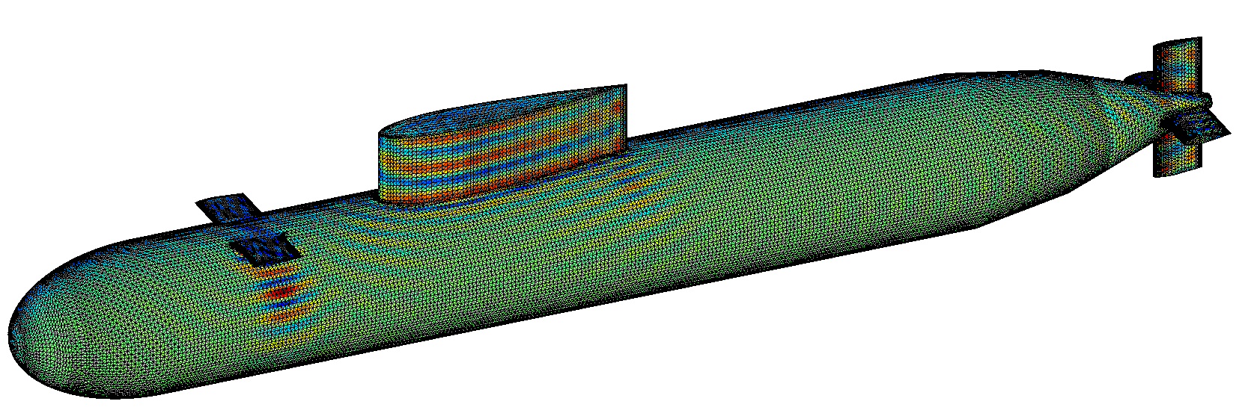
Acoustic pressure on the surface of a submarine due to a 1 kHz plane wave at broadside incidence computed using the Fast Multipole Boundary Element Method (FMBEM).

Array Processing & Acoustic Tracking
CMST staff have developed array processing algorithms to allow tracking of acoustic sources with systems ranging in complexity from one to sixty hydrophones. These include algorithms that can beamform from moving, distorting arrays and are applicable to the towed arrays used by submarines. This work has also included the inverse problem of estimating the array shape from the hydrophone outputs. Other work in this area includes the automated detection and classification of signals originating from different types of sources.

Underwater Acoustic Propagation Modelling
CMST carries out research in underwater acoustic propagation modelling with a focus on improving the limited accuracy of conventional acoustic propagation models when applied to propagation over much of Australia's continental shelf. A consequence of the age of the Australian continent and its aridity is that a large proportion of its continental shelf consists of soft limestone with very little overlying sediment. This combination poses a particular problem for traditional underwater acoustic propagation models, which CMST is working to address. CMST has also developed tools that allow it to predict underwater sound levels over wide geographical areas, which are relevant to submarines in assessing likely ambient noise fields and signal strengths when predicting the performance of passive and active sonar systems.

Measurement of the Marine Soundscape around Australia
CMST has an extensive set of long-term, high-quality, well calibrated underwater sound recordings made at hundreds of locations around Australia. These measurements can feed into predictive ambient noise models for assessing the likely performance of military sonar systems as a function of time and location.
Comparison between measured (left) and simulated (right) spreading functions for a shallow-water communication channel.
Underwater Acoustic Communications
CMST's work in underwater acoustic communications focuses on developing tools to simulate the effect that propagation through a changing water column has on underwater communication signals. This work has included measurements of the time-varying characteristics of a number of acoustic propagation paths and the incorporation of these results into predictive software.

Specialist Teaching
CMST staff run specialist units and short-courses in hydrodynamics and marine acoustics.

CMST Personnel
CMST has a team of fifteen multi-skilled physicists, biologists and engineers. Staff who work in areas relevant to Defence include:

Alec Duncan, PhD, MSc
Senior Research Fellow in underwater acoustics, with 30 years’ experience in propagation modelling, sonar array processing, signal processing and data analysis. Also teaches marine acoustics and general physics.

Christine Erbe, PhD, MSc
Director of the Centre for Marine Science and Technology with 23 years' experience in underwater acoustics, with an emphasis on the characterisation of the marine soundscape, sound propagation, signal processing, and the effects of noise on marine fauna.

Alexander (Sasha) Gavrilov, PhD, MSc
Associate Professor in acoustical oceanography, with 25 years’ experience in acoustic propagation, field measurements and benthic habitat mapping.

Tim Gourlay, PhD
Senior Research Fellow in ship hydrodynamics and wave mechanics. Also teaches hydrodynamics and ship science.

Rob McCauley, PhD, BSc
Associate Professor in marine bioacoustics with 23 years’ experience, specialising in the measurement of noise in the ocean and the effects of noise on fish and marine mammals.

Daniel Wilkes, PhD, BSc
Research Scientist in numerical modelling of acoustic interactions with structures.

