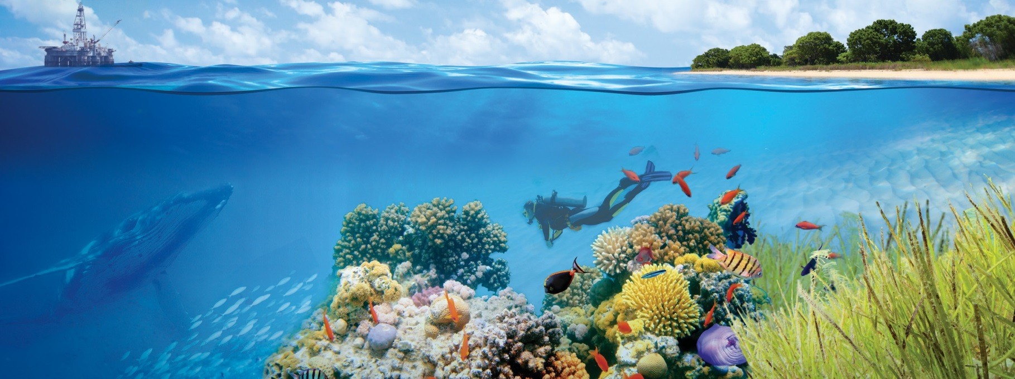

LIVING COASTS AND SEAS
Advancing marine research and discovery at Curtin

Sonar Imaging
The Centre for Marine Science and Technology (CMST) has expertise in collecting, processing and analysing data from a variety of sonar and echosounder systems. Researchers have developed sonar imaging software tools, some of which are now publicly available. These tools have been utilised in multiple CMST projects in the areas of habitat mapping, seafloor bathymetry and composition mapping, biomass mapping, fisheries surveys, environmental monitoring of dredge plumes and gas seeps, internal waves and detecting marine megafauna (including sharks along Western Australian beaches).
CMST’s research assets include:
- Multibeam echo-sounder
- Scientific single beam echo-sounders
- Sidescan sonar
- Underwater video system
- Grab sampler
- Seabird CTD system
- Multiple pressure/temperature and pressure sensors
- Bespoke Matlab Sonar processing suites
- Fledermaus, Quinsy, Hypack, CARIS software licenses
Team
Dr Alec Duncan
A/Prof Alexander Gavrilov
A/Prof Rob McCauley
Dr Iain Parnum
Dr Miles Parsons
Contact: Dr Iain Parnum
Email: I.Parnum@curtin.edu.au

Centre for Marine Science and Technology

Make tomorrow better. research.curtin.edu.au

